**Lo2- Be able to plan the creation of a digital game**

I have been asked to make a game by the company called triangle games. The name of the game is ‘working time’. The aim of the game to get to work on time, dodging the specified objects and NPCs. I will also add collectibles.

The will be a choice of wolf, gorilla, lion, giraffe and elephant characters. I will use the gorilla character in an Indi-silhouette theme. This will incorporate the gorilla’s strength to push items and break things. The levels I have been told to make are a jungle, a river, a tower block and a city. I only need one of these but I may add more later in development.

* The jungle has to have tigers.
* The river has to have ‘hungry’ crocodiles.
* The city should have cars that you dodge.
* The tower block should have platforms to get higher and gaps that cannot fall down.
* I plan for the main theme of my level to be Japanese architecture, with the fall that kills the player to be from dojo-like roofs into water. Other obstacles could be spikes, saw blades and swinging balls.

I will also make a short tutorial and a playable level select screen.

The graphics will be simple and easy to understand, possibly silhouette art for the main layer. I will add lots of decoration as well to make the game feel unique.

Some examples are:

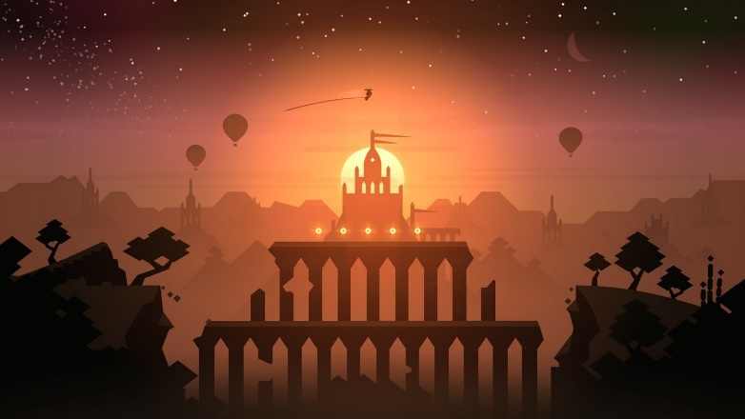Alto’s adventure-

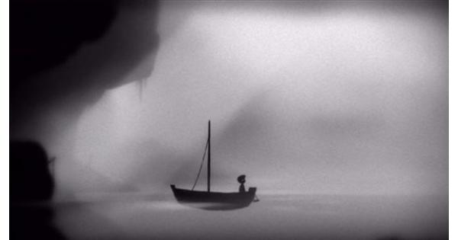Limbo-

I plan to make the background coloured but the solid objects in the foreground black.

We also have to add a 60 second time limit at the start. This will make the player feel rushed and generally speed up the pace of the game.

I will add power-ups that freeze, slow, or add back time. There will also be power ups that speed the player. The purpose of powerups is often to make the following section easier, and is used in lots of games.

Hollow knight for example has many collectible abilities that help or enable you to complete sections of the game-

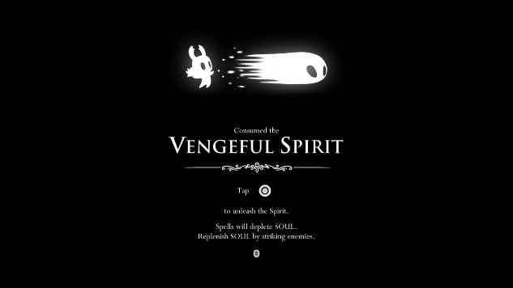-‘Vengeful spirit’ does more damage than the standard attack by default.

In my game I plan on placing the powerups in areas that without them would be difficult to complete. This adds variety and a more cause and effect related gameplay.

Some parts of my game will be harder, specifically three different routes through the level, the higher ones being the most difficult. This is where there will be more powerups. In lots of games the harder routes have more reward, so I will add more of the bonus points to these routes to encourage players to replay the game for the higher score.

The brief also states that if you hit more than two obstacles you have to reset, meaning you can have three health. I will add pickups that add health back on, but to no more than the original amount.

The game is to be aimed at 10- 16 year olds, because the target is a minimum of PEGI 7 rating (PEGI stands for Pan European Game Information). This means that my game must follow these rules:



No actions in my game justify ‘frightening’ sounds effects, so I will not need any.

There is no forms of violence, neither implied nor non-graphical.

Originally I was going to make a ‘gambling’ mini-game, but it would mean that my game is rated a 16 so I had to change my plans.